**Tesselations**

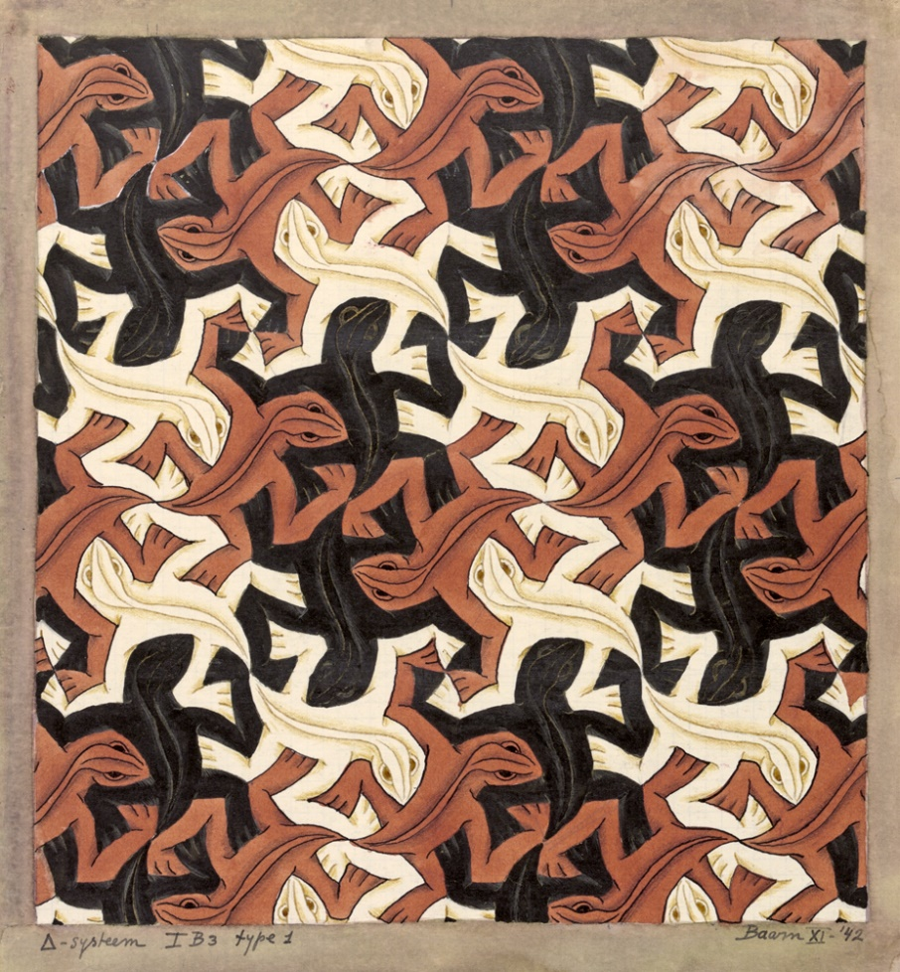

This is a reproduction of M.C.Escher’s tessellating lizards.These are relatively complicated shapes to tesselate, but can you answer the following.

Do all quadrilaterals tesselate? If so can you prove it, of not give a counter-example.

Can you also demonstrate how it is possible to construct tessellating shapes.

**Voting**

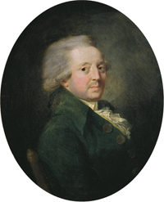

***The Marquis de Condorcet***

A group of 100 people need to elect a new prime minister. There are three candidates for the role, and everyone has an opinion on their favourite, second favourite and least favourite candidate.

Other than asking everyone to vote for one candidate and pick the person with the most votes what alternative systems are there and what are the advantages/disadvantages of each?

**Opera House**

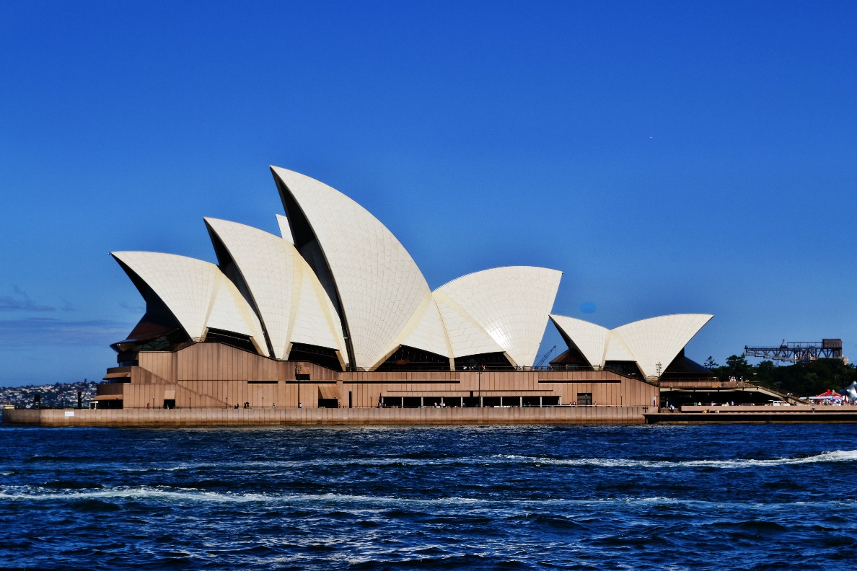

This is a picture of the Sydney Opera House.

Can you describe the shape of this building mathematically?

**Octopus**

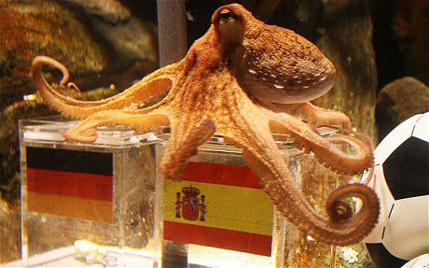

This is a picture of Paul the Octopus. He correctly predicted the result of every game involving Germany in the 2010 World Cup.

Was he psychic or lucky? Use probability to assess likelihood of making these predictions correctly and try to answer this question.

**Stars**

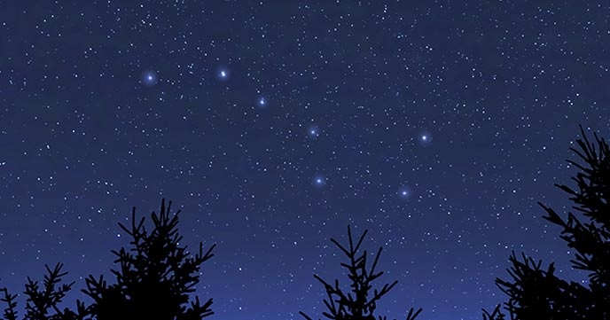

In the above image the constellation of Ursa Major is highlighted, but how far away are these stars and how do we measure the distance to the stars?

**Marathon**

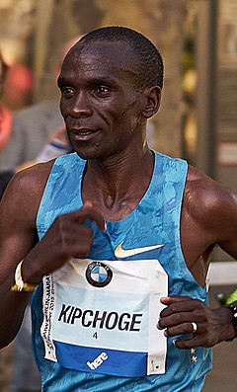 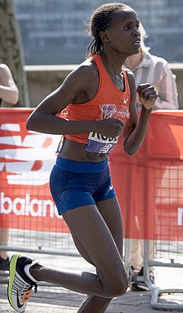

Eliud Kipchoge and Brigid Kosgei currently hold the world record times for the marathon. But how has this record changed over time? Has the improvement in times followed a linear trend, what do you think could happen in the future?

**Medicine**

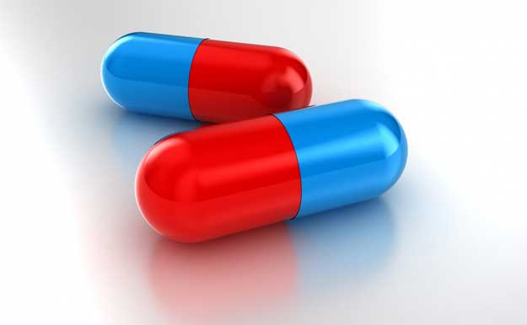

Medicines have a half-life. For example, a medicine is broken down by the body so that half of the remaining dose in the system is broken down every 6 hours.

If somebody takes a 500mg dose of medicine in the morning and 500mg of medicine in the evening (12 hours later) over a long period of time what will be the long-term effective level in their system?

Given a desired level for a medicine in the body could you devise a technique for doctors to administer medicine in order to achieve this level.   
 